2.0 Entity-Relationship Model

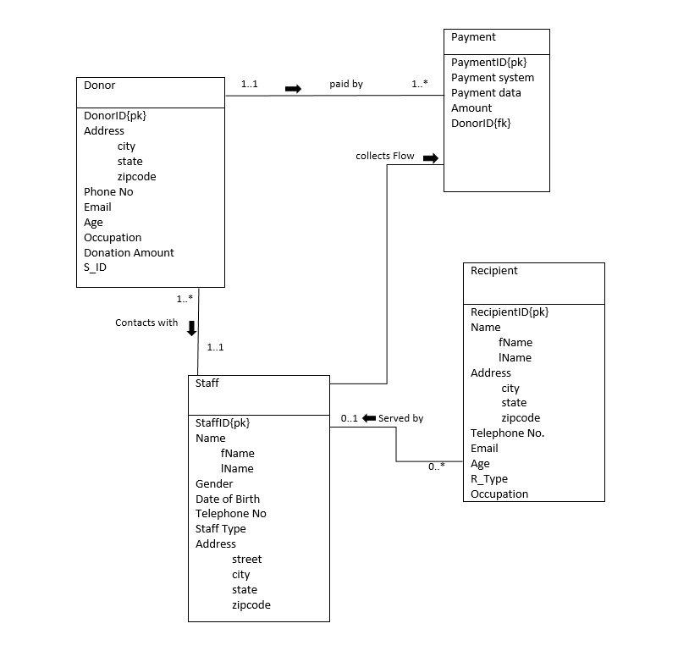

3.0 LOGICAL DATABASE DESIGN

Donor (Donor_Id, fName, lName, city,state,zip, telNo,email,age, occupation,donation amount ,S_ID)

Primary key – customer_Id
Foreign Key – S_ID
Staff (S_Id, fName, lName, gender, DOB, telephone_No,S_type, street,city,state,zip code)

Primary key – staff_Id
Payment (P_ID, P_system , P_date, amount_No )

Primary Key - P_ID
Foreign Key - Donor_ID

Recipient - (R_ID,fName,lName,city.state,Zip,telephone_No,email,age,R_Type,occupation)

Primary Key - R_ID

4.0 PHYSICAL DATABASE DESIGN

Create Table Donor
(
Donor_Id varchar(5) not null,
fName char(6),
lName char(6),
city char(7),
state varchar(8),
Zipcode number(6),
TelNo number(11),
Age number(3),
Occupation char(9),
S_ID varchar(6),
PRIMARY KEY (customer_Id),
FOREIGN KEY (S_ID)
);

Create Table Staff
(
s_Id varchar(5) not null,
fName char(6),
lName char(6),
gender char(6),
DOB date,
telNo number(11),
S_type char(10),
Street char(10)
city varchar(10),
state varchar(10),
zipcode number(6),
PRIMARY KEY (S_Id)
);

Create Table Payment

(
P_ID varchar(8) not null,
P_system char (9),
P_date varchar (8),
Amount_No number (8),
Donor_ID varchar (5)not null
PRIMARY KEY ( P_ID),
FOREIGN KEY ( Donor_ID)

);

Create table recipient

(
R_ID varchar(10),
fName char(10),

Lname char(10),
City char(10),
State char(10),
Zip number(6),
Telephone_No number(11),
Age number(3),
R_Type varchar(6)
Occupation char(10)
PRIMARY KEY (R_ID)

)

insert into Donor values ('C1569', 'Imtiaz', 'Sakib', 'Gombak', 'Selangor',53100, 0182874247,25,’Doctor’, 'S1040');

insert into Donor values ('C1420', 'Yang', 'Hao', 'Setapak', 'KL',54050,0185683756, 30,’Pilot’, 'S1040');

insert into Donor values ('C1430','Jack',’Frost’,’Gombak’, 'Selangor',53200,011567384, 40,’Writer’, 'S1852');

insert into Donor values ('C1179', 'Piggy', 'Quene', 'KL', 'KL',50960,01115698346, 45,’Teacher’, 'S1902');

insert into Donor values ('C2497', 'David', 'Thomas', 'Setapak', 'KL',54470,0183294618, 50,’Banker’, 'S2506');

insert into Staff values ('S1040','John','White','Male',to_date('01/11/1965','dd/mm/yyyy'),0184236952,'Manager','205 Lane’,'Setapak','KL',54470);

insert into Staff values ('S2506','Ann','Beech','Female',to_date('10/10/1980','dd/mm/yyyy'),0114521252,'Assistant','1_Old road','Sri rampai','KL',54230);

insert into Staff values ('S1525','David','Ford','Male',to_date('24/03/1978','dd/mm/yyyy'),0185258563,'Supervisor','JLN p5','Putra Jaya','Putra Jaya',62200);

insert into Staff values ('S1852','Marry','Howe','Female',to_date('19/02/1985','dd/mm/yyyy'),0187478846,'Assistant','Semarak','Cyberjaya','Selangor',63000);

insert into Staff values ('S1902','Nabil','Showki','Male',to_date('21/08/1988','dd/mm/yyyy'),0186936321,'Supervisor','Putra Ht','SubangJaya','Selangor',40400);

insert into Payment values('P00025','Cash',to_date('03/01/2017','dd/mm/yyyy'), 1300,'C1569');

insert into Payment values('P00028','Card',to_date('17/01/2017','dd/mm/yyyy'), 600,'C1420');

insert into Payment values('P00031','Card',to_date('14/02/2017','dd/mm/yyyy'), 300,'C1430');

insert into Payment values('P00037','Card',to_date('28/02/2017','dd/mm/yyyy'), 400,'C1179');

insert into Payment values('P00041','Cash',to_date('06/03/2017','dd/mm/yyyy'), 1500,'C2497');

Insert into recipient values('R102','Kuddus','Boyati','KL','KL',50088,0171225865,63,'Fakir','Watchman');

Insert into recipient values('R103','Khan','Helal','SubangJaya','Selangor',47500,01526733,48,'Miskin','Labour');

Insert into recipient values('R201','Maal','Muhith','Setapak','KL',53300,0885203455 ,39,'Garimin','Sweeper');

Insert into recipient values('R205','Ahsan','Habib','Ampang','KL',55000,017122081656,53,'Riqab','Beggar');

Insert into recipient values('R309','Mitila','Mujib','Setia Alam','ShahAlam',25000,01521428011,27,'Miskin','Unemployed');

Insert into recipient values('R405','Naila','Nayem','WangsaMaju','KL',54820,01623019070,32,'Fakir','Plumber');

5.0 SAMPLES QUERIES

5.1 Basic queries

Q1.1 Insert record for 1 donor named ‘Amad soleman’

insert into donor values('C2991', 'Amad', 'solem','KL','KL',63000, 0189541292,69,'Actor','S1040');

Q1.2 Change amount with ID P00025 from 1300 to 1400

update payment set amount_no = 1400 where P_ID = 'P00025';

Q1.3 Delete record for 1 payment with ID P00025

delete from Payment where p_Id = 'P00025';

Q1.4 Insert record for 1 payment with ID P10025

insert into payment values('P10025', ‘Cash’,to_date('03/01/2016', 'dd/mm/yyyy'), 700, 'C2991');

Q1.5 Change staff with ID S1902 tel_no from 0186936321 to 0186999999

update Staff set tel_no = 0186999999 where s_Id = 'S1902';

5.2 Operational queries

Q 2.1 - List Donors who donated more than 600 RM.

Select d.donor_ID, d.fName , d.lName, p.P_ID, p.P_date
From donor d , payment p
Where d.Donor_ID = p.Donor_ID and p.amount_No>600
Order by p.P_date;

Q 2.2 - List donation information processed by staff ‘Nabil showki’

select s.S_ID , s.fname , s.lName , d.Donor_ID
From staff s , donor d
Where s.S_ID=d.S_ID and s.S_ID='S1902' ;

Q 2.3 - List donor and staff information where both lives in state ‘KL’

Select d.donor_ID , d.fName , s.S_ID, s.fName
From donor d , staff s
Where d.S_ID = s.S_ID and s.state= 'KL' and d.state='KL' ;

Q 2.4- list donor information paid after 1st February, 2017

Select p.P_ID, d.donor_ID ,d.fName ,p.P_System,p.Amount_no
From donor d , payment p
Where d.Donor_ID=p.Donor_ID and p.P_Date>'01-Feb-2017' order by d.donor_ID;

Q 2.5 -List information of donors with first letter 'D'

select donor_ID,fName , lName , occupation , age
from donor
where fName like 'D%';

5. 3 Strategic queries

Q3.1 List number of recipients based on recipient type

Select R_Type, count(R_ID) as No_Of_Recipient
From recipient
Group by R_Type;

Q3.2 Total number of Donor who donated more than 350
Select COUNT(*)AS total_donor
FROM payment
Where amount_no >350;

Q3.3 List maximum money given by donor

Select MAX(Amount_no)AS Highest_Amount
FROM payment;

Q3.4 Total number of donation management process by individual staff who dealt with more than one donor

select s.S_Id, concat(s.fName, s.lName) as Name, count(d.donor_Id)
from staff s, donor d
where s.S_Id = d.S_ID
group by s.S_Id, s.fName, s.lName
having count(d.donor_ID) > 1;

Q3.5 Find all the donors who contributed amount that is larger than the donation of at least a donor who gave more than 600 RM.

Select fName , lName , occupation , age
From donor
Where Donor_ID > some (select Donor_ID from payment where Amount_No='600');

5.4 User Views

Q4.1 Create a view for Staff

Create view Staff_List as select s.fName , s.lName ,s.Gender, d.Donor_ID,d.occupation
from staff s , donor d
where s.S_ID=d.S_ID;

Q4.2 Create a view for the staffs to supervise the zakat management process conveniently

Create view reserved_by as select d.Donor_ID, p.Amount_No, r.R_Type,r. R_ID as processed_BY
From Donor d , payment p , recipient r
Where d.Donor_ID= p.Donor_ID;

Q4.3 Create a view for the payment system receiver to integrate donors and staffs contribution

Create view relation_of as select s.S_ID , s.fName , s.lName, s.DOB, d.Donor_ID, d.occupation as processed_BY
From Donor d , staff s
Where s.S_ID= d.S_ID;

6.0 RECORD LISTING

DONOR RECORDS

Donor_id | fName | lName | Age | tel_no | city | state | zipcode | Occupation | S_ID
C1569 | Imtiaz | Sakib | 25 | 0182874247 | Gombak | Selangor | 53100 | Doctor | S1040
C1420 | Yang | Hao | 30 | 0185683756 | Setapak | KL | 54050 | Pilot | S1040
C1430 | Jack | Frost | 40 | 0115698346 | Gombak | Selangor | 53200 | Writer | S1852
C1179 | Piggy | Quene | 45 | 0115673284 | KL | KL | 50960 | Teacher | S1902
C2497 | David | Thomas | 50 | 0183294618 | Setapak | KL | 54470 | Banker | S2506

STAFF RECORDS

Staff_id | fname | lname | Gender | dob | position | tel_no | street | city | state | zipcode
S1040 | john | white | M | 1/11/1965 | manager | 0184236952 | 205 lane | setapak | KL | 54470
S2506 | ann | beech | F | 10/10/1980 | assistant | 0114521252 | 1, old road | sri petalin | KL | 54230
S1525 | David | ford | M | 24/03/1978 | supervisor | 0185258563 | jln p5 | wp putrajaya | putrajaya | 62200
S1852 | Marry | howe | F | 19/02/1985 | assistant | 0187478846 | persemarak | cyberjaya | selangor | 63000
S1902 | Nabil | showki | M | 21/08/1988 | supervisor | 0186936321 | putra height | subang  jaya | selangor | 40400

PAYMENT RECORDS

P_id | Date | Amount_No | Donor_id | Payment_Type
P00025 | 03/01/2017 | 1300 | C1569 | Cash
P00028 | 17/01/2017 | 600 | C1420 | Card
P00031 | 14/02/2017 | 300 | C1430 | Card
P00037 | 28/02/2017 | 400 | C1179 | Card
P00041 | 06/03/2017 | 1500 | C2497 | Cash

RECIPIENT RECORDS
R_id | F_name | L_name | Occupation | Phone number | Age | R_Type | City | State | Zipcode
R102 | Kuddus | boyati | Watchman | 017125865 | 63 | Fakir | KL | KL | 50088
R103 | Khan | helal | Labour | 01526733 | 48 | Miskin | Subangjaya | selangor | 47500
R201 | Maal | Muhith | Sweeper | 0885203455 | 39 | Garimin | Setapak | KL | 53300
R205 | Ahsan | Habib | Beggar | 017122081 | 53 | Riqab | Ampang | KL | 55000
R309 | Mithila | Mujib | Unemployed | 01521428011 | 27 | Miskin | setia alam | shah alam | 25000
R405 | Naila | Nayem | Plumber | 019 | 32 | Fokir | wangsa maju | KL | 54820

